1. INTRODUCTION
zkDietFormer: Verifiable Transformer with Linear-Cost Attention Proofs via Low-Rank Approximation

(Abstract) The deployment of Transformer models via Model-as-a-Service (MaaS) platforms raises a trust problem: users cannot verify that the provider faithfully executed the claimed model. Zero-knowledge SNARKs can prove correct inference without revealing model weights, yet existing approaches face an O(n²) proving-cost bottleneck from the n × n self-attention matrix. We propose zkDietFormer, the first zero-knowledge verification framework for low-rank self-attention. By instantiating the Nyström approximation inside the proving circuit, we replace the full attention computation with three smaller matrix products involving m ≪ n landmark tokens, reducing the dominant cost to O(n). Freivalds’ randomized checks verify all matrix products, and a commit-carrying SNARK binds every proof to a single committed model. Experiments on five BERT-scale configurations show up to 4× extension in maximum provable sequence length under 128 GB memory, with per-layer prove time growing near-linearly in n.

Modern large language models are deployed via remote inference APIs where users cannot inspect the computation. Zero-knowledge proofs (ZKPs) offer a principled solution: the provider proves correct inference without revealing model weights, which constitute the provider’s core intellectual property. However, self-attention—the core Transformer operation—forms an n × n attention matrix with row-wise softmax, creating an O(n²) bottleneck in both computation and proof generation. As context windows grow from 512 tokens to millions in frontier models, quadratic verification cost becomes prohibitive. Probabilistic techniques such as Freivalds’ algorithm [1] and sumcheck protocols [4] reduce matrix-multiplication verification cost but leave the O(n²) term intact.
Meanwhile, attention matrices often exhibit approximate low-rank structure, and Nyströmformer [2] exploits this to achieve O(n) inference cost with accuracy comparable to standard self-attention. We present zkDietFormer, which combines: (1) Nyström low-rank decomposition, reducing the attention circuit from O(n²) to O(n); (2) Freivalds’ randomized checks, verifying matrix products via vector inner products; and (3) a commit-carrying SNARK (CC-SNARK) [3], binding each proof to committed model weights outside the circuit.

2. METHOD

Nyström Low-Rank Attention. Standard self-attention requires forming an n × n attention matrix via softmax of the query-key product, then multiplying by values V. Nyströmformer [2] avoids this by partitioning the sequence into m segments, computing m landmark queries and keys by segment averaging. This yields three low-rank factors of sizes n×m, m×m, and m×n, with the m×m factor’s pseudoinverse replacing the full n × n inversion (Fig. 1). Since all products involve at most n × m entries, the total cost is O(n) for fixed m.
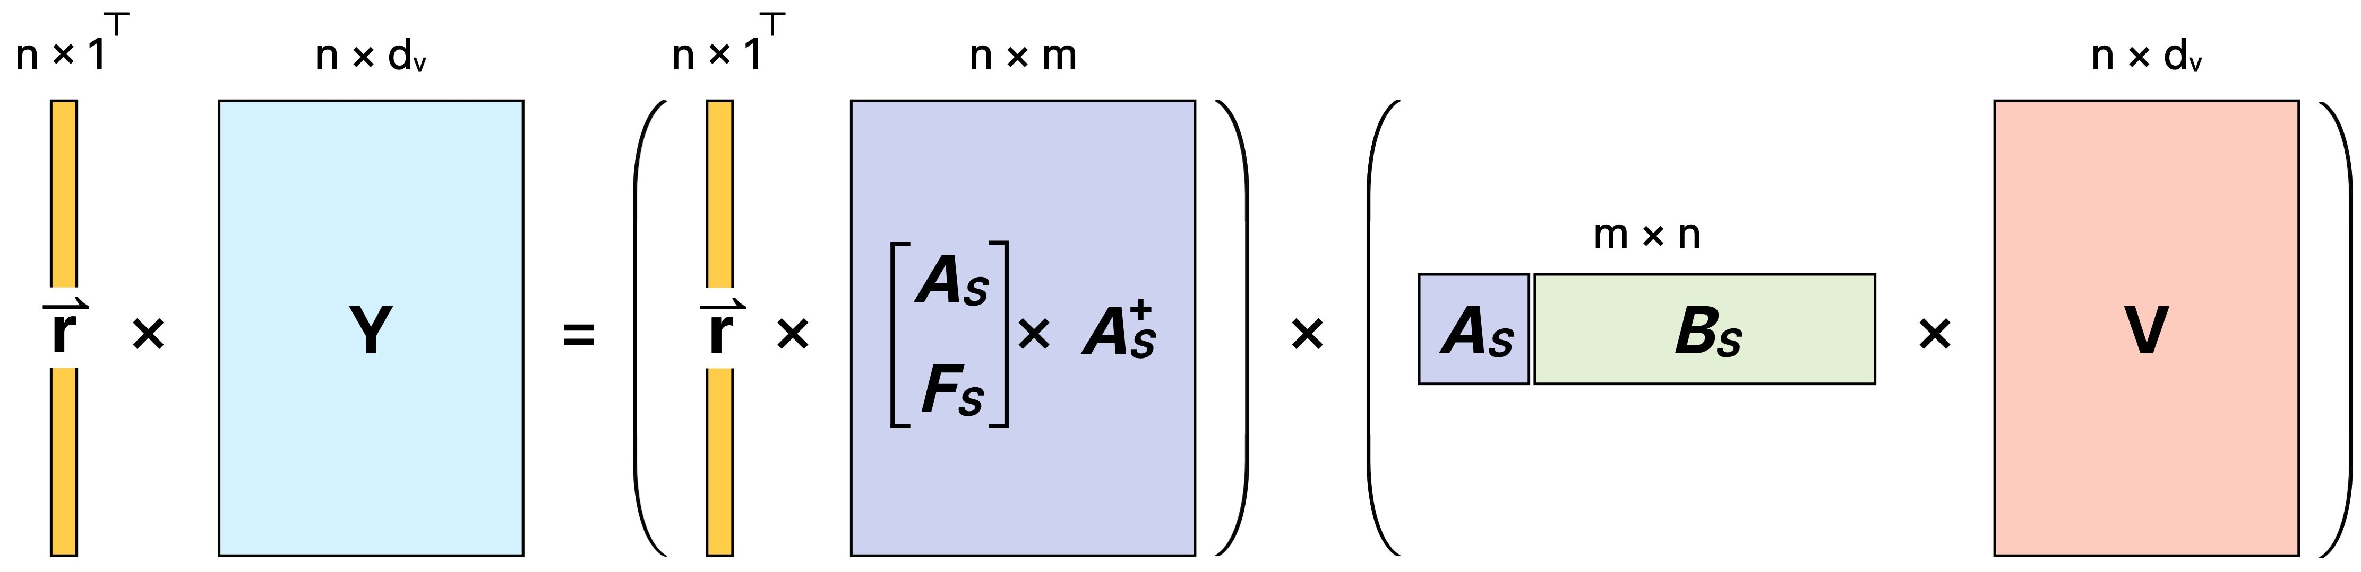
Fig. 1. Nyström low-rank decomposition of self-attention with Freivalds’ random projection check.

Freivalds’ Verification. To verify a claimed matrix product AB = C without recomputing it in O(n³), Freivalds’ algorithm [1] checks ABr = Cr for a random vector r, reducing verification from O(n³) to O(n²) for n × n matrices—or O(nm) for n × m products. We apply this to every large product in the Nyström pipeline, making total in-circuit cost linear in n.
Lookup Arguments for Non-Linear Functions. Non-arithmetic operations such as the softmax exponential cannot be expressed efficiently as arithmetic constraints; a lookup argument instead proves that each claimed input-output pair belongs to a precomputed table of the quantized function.
Commit-Carrying SNARK and CP-Link. A commit-carrying SNARK (CC-SNARK) [3] is a SNARK whose prover outputs, alongside the proof, a commitment cm to a designated part of the witness, generated during proving under a circuit-dependent key. This moves the expensive commitment computation outside the circuit, so large witnesses, in our case the weight matrices and the intermediate products, are cryptographically bound to the proof at little constraint cost. In practice, a CC-SNARK is paired with a CP-link proof, which asserts that the commitment it emits and a commitment formed under a separate, circuit-independent key open to the same values.
Overall Protocol. zkDietFormer is a tuple of five algorithms, zkDIET = (KeyGen, Setup, Commit, Prove, Verify). Key generation is split in two because the two commitment layers serve different purposes: one binds the model across its entire lifetime, the other binds a single proof.
- KeyGen outputs a circuit-independent commitment key, sampled once and shared by every circuit configuration the provider may later deploy. Setup outputs a circuit-dependent commitment key together with the proving and verification keys for the attention relation; it runs once per architecture, not per query. Commit publishes the global weight commitment $c_{W}$ under the circuit-independent key. Issued once before any query, $c_{W}$binds every subsequent response to one and the same model, so the provider cannot silently swap weights between queries. Prove evaluates the attention pipeline outside the circuit and generates a CC-SNARK proof for the entire attention computation, including every matrix product verified via Freivalds’ algorithm and every softmax evaluation proven via the lookup argument. It returns the proof, the per-proof commitments cm, and a link proof asserting that cm and $c_{W}$ open to the same weights. Verify accepts only if the CC-SNARK proof, the CP-linkage against $c_{W}$, and the lookup argument all pass.

3. EXPERIMENTAL RESULTS

We implement zkDietFormer with LegoGroth16 [3] as the CC-SNARK backend and Lasso [5] as the lookup argument. We benchmark standard BERT attention against Nyströmformer attention [2] across five BERT-family configurations, Tiny (L=2, d=128), Mini (4, 256), Small (4, 512), Medium (8, 512), and Base (12, 768), on an Apple M1 Ultra with 128 GB unified memory (CPU only). All metrics are per single layer averaged over L layers.
Fig. 2 reports a 2×2 factorial design on the Tiny configuration, crossing the attention kernel (BERT vs. Nyström) with the verification method (naive vs. Freivalds) to isolate each technique’s contribution. Each technique alone yields a constant-factor gain, and the two are complementary: at n=256 the full combination reduces constraints by 4.1× (39.22M to 9.55M), prove time by 4.8× (345.44s to 72.02s), and peak memory by 2.0× (112.13GB to 56.25GB) over the BERT-naive baseline. It is also the only variant that remains provable at n=1024, where all others exhaust the 128GB budget.
Fig. 3 sweeps the model family from Tiny to Base, plotting per-layer prove time for the attention computation against sequence length. BERT’s curves rise quadratically while Nyström’s grow near-linearly, and the gap widens with model size: at Base (d=768), BERT reaches at most n=512 within the memory budget, whereas Nyström extends to n=2048, a 4× longer provable sequence.
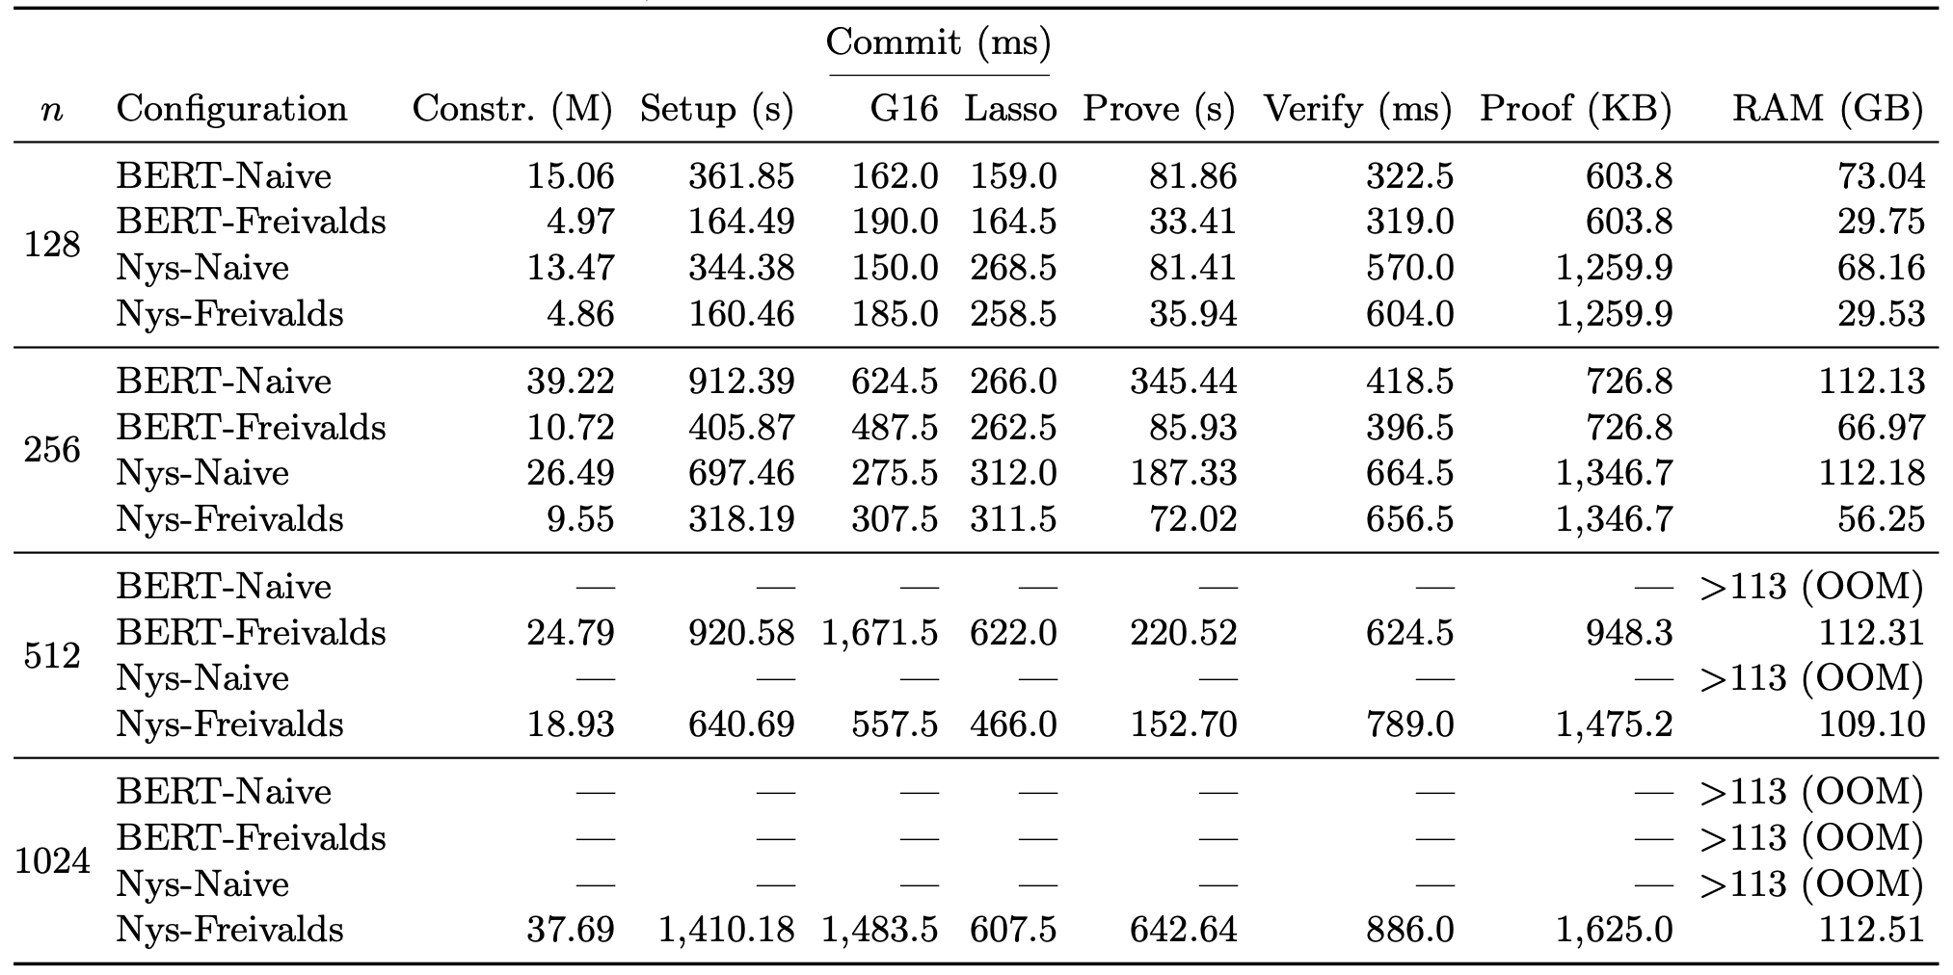
Because ZK circuits operate over a finite field, real-valued Transformer arithmetic must be quantized to fixed-point form before proving, raising the question of whether the proven model still behaves like the original. Table 1 answers affirmatively: under 26-bit fixed-point precision, a pretrained Nyströmformer evaluated through all 12 layers agrees with its floating-point counterpart on 98.8% of top-1 predictions, with logit cosine similarity 0.9975, confirming that the verified computation is faithful to the deployed model.
Fig. 3. Per-layer attention prove time vs. sequence length n

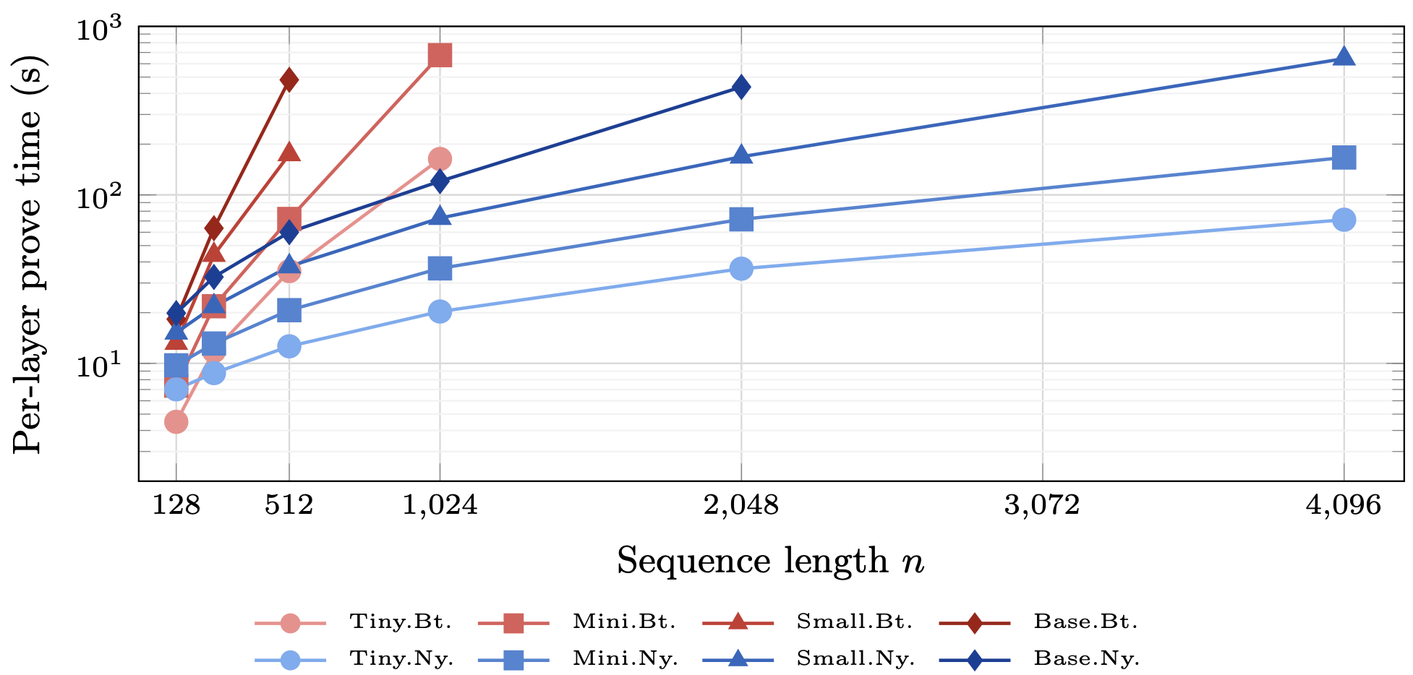
Fig. 2. Attention kernel × verification method on Tiny
Top-1 Agree. (%) |  | Top-5 | Cosine | RMSE
All pos. | Mask pos. | All (%) | Sim. | (logit)
98.8 | 90.0 | 100.0 | 0.9975 | 0.378
Table 1. Quantization fidelity of 26-bit fixed-point arithmetic

4. CONCLUSION

zkDietFormer demonstrates that low-rank attention structure can be systematically exploited for linear-cost zero-knowledge proofs. The combination of Nyström approximation with Freivalds verification yields multiplicative constraint savings and extends the scalability boundary of verifiable Transformer inference.

References

[1] Freivalds, R. Probabilistic machines can use less running time. In IFIP Congress (1977)
[2] Xiong, Y. et al. Nyströmformer: A Nyström-based algorithm for approximating self-attention. In AAAI (2021)
[3] Campanelli, M. et al. LegoSNARK: Modular design and composition of succinct zero-knowledge proofs. In CCS (2019)
[4] Thaler, J. Time-optimal interactive proofs for circuit evaluation. In CRYPTO, pp. 71–89 (2013)
[5] Setty, S., Thaler, J., Wahby, R. Unlocking the lookup singularity with Lasso. ePrint 2023/1216 (2023)

